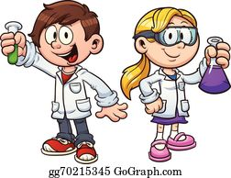
Fun Science Activities

Family Self Guided Science Experiments

Hello Everyone. Summer camp is on at Aspen Ranch Outdoor Education Facility. ( Sponsored by Camps for Children Educational Association and Minds in Motion U of C )

Our answer to the Covid19 restrictions and protocols for a safe learning environment in a summer camp setting is to come and perform Family Self Guided Science Experiments at our center. Open weekdays from July 27 to August 21.

Book a time now on line at info@aspenranchcanada.com for your family to exclusively come into our classroom and perform neat science labs. Our labs are geared for grade 3 to grade 6 students with a parent present to help guide them and combined these could take one hour to complete. All the materials need are supplied free to you, as well as instructions on how to perform the activities at our pre-set stations.

Here are some of the labs you can perform:
- Make a Paperclip Float
- Magic Milk
- Build a Soap Powered Boat
- Make an Electromagnet
- Chromatography

After you’ve completed the labs, as a family unit with parents supervising, you can also do a one hour self-guided tour of our beautiful grounds and marvel at the wonders of nature; wildlife mammal, birds, reptiles, insects, and plants. You could also have a family picnic after the walk at our outside eating area.

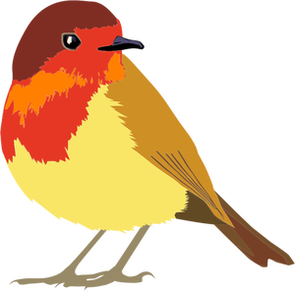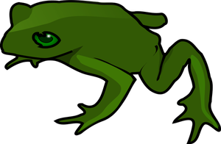
Here is how to get to our center, connect to our Google maps link at
http://www.aspenranchcanada.com/contact_info/index.htm

